Beyond Residence: Mobility Driven PM_{2.5} Exposure Disparity in the Washington, D.C. Metro Area
Jin Hyuk Son
The George Washington University
Abstract
Standard environmental justice (EJ) research assign pollution exposure based on residential location, overlooking the potential pollution burdens people accumulate through daily mobility. This study investigates mobility driven PM_{2.5} exposure disparity in the Washington, D.C. metro area (DMV) from January 2018 through November 2021, spanning 2,548 census block groups (CBGs) and approximately 4.2 million residents. Using high-resolution (1km) monthly PM_{2.5} estimates from the Global High-resolution Accurate PM_{2.5} (GHAP) satellite rasters, anonymized mobility flows from SafeGraph, and demographic data from the American Community Survey (ACS), we construct a mobility-adjusted exposure variable defined as the visitor-weighted mean of destination minus origin exposure for each CBG. Across the study period, 80.7% of the DMV population lives in census block groups where daily travel increases PM_{2.5} exposure, with a population-weighted mean differential of +0.451 µg/m³. Spatial error models reveal a spatial trap: the effect of racial composition on mobility-driven exposure shrinks by 67.8% from suburban to urban residential PM_{2.5} levels, as nonwhite communities already in high-pollution areas have no mobility pathway to cleaner air. The COVID-19 pandemic - which halved mobility-driven exposure differentials in 2020 - provides experimental evidence that daily travel is the causal mechanism generating this disparity. Income shows no independent effect once spatial autocorrelation is controlled. These findings call for dynamic, mobility-aware exposure frameworks in EJ research and policy.

Keywords: environmental justice; PM_{2.5;} human mobility; SafeGraph; GHAP; spatial error model; Washington D.C.; spatial trap

1. Introduction
Ambient fine particulate matter (PM_{2.5}) exposure ranks among the leading environmental determinants of cardiovascular and respiratory morbidity globally, contributing to an estimated 4.2 million premature deaths annually.¹ In the United States, the burden of PM_{2.5} exposure is not distributed equitably: communities of color and low-income populations consistently face higher ambient concentrations, a pattern extensively documented in the environmental justice (EJ) literature.² These studies have shaped regulatory frameworks, such as the Biden administration's Justice40 initiative, which directs federal investment toward disadvantaged communities defined in part by residential pollution burden.³
A critical but underexplored dimension of EJ is the role of human mobility. People do not remain in their residential neighborhoods throughout the day: they commute to workplaces, visit commercial destinations, and engage in recreational activity. Each of these trips exposes individuals to pollution levels that may differ substantially from their residential environment.⁴ Residential-based exposure metrics, which assign pollution exposure based solely on home location, therefore systematically mischaracterize the true environmental burden borne by mobile individuals.⁵
The problem of mobility-based exposure mischaracterization has received growing theoretical attention. Su et al.⁶ demonstrated that integrating smartphone-based location tracking with fixed-site monitoring substantially changes individual exposure estimates relative to residential methods. Jbaily et al.⁷ showed that mobility-adjusted exposure can alter the magnitude and direction of apparent EJ gradients in some contexts. Despite this body of work, few studies have implemented mobility-based EJ analyses at fine spatial resolution over multi-year periods, and rarely have any studies examined the Washington, D.C. metropolitan area.
The Washington, D.C. metropolitan area (DMV) offers an instructive setting for this analysis. The region is characterized by high transit dependency among lower-income and nonwhite residents, concentrated employment in the urban core, and suburban commuter corridors that funnel workers into downtown environments with elevated PM_{2.5.} Its approximately 4.2 million residents across 2,548 CBGs provide sufficient resolution for spatial analysis.⁸ The 2018-2021 study window also coincides with the COVID-19 pandemic, during which the collapse of normal mobility patterns offers a way to assess whether daily travel is driving the exposure gap.
Advances in data availability make this analysis tractable. The GHAP dataset⁹ provides satellite-derived PM_{2.5} estimates at 1 km spatial resolution and monthly temporal resolution, validated at R² = 0.97 against EPA ground monitors. SafeGraph's monthly patterns product¹⁰ provides anonymized CBG-to-point-of-interest mobility flows for the full study period. Combined with ACS demographic data,¹¹ these sources enable a fully integrated pipeline from satellite observation to spatial regression that is reproducible and transferable to other metropolitan areas.
This paper examines whether daily mobility systematically increases PM_{2.5} exposure and whether that burden falls unevenly across demographic groups. It further explores whether nonwhite communities already living in high-pollution areas face a compounding disadvantage - not just high residential exposure, but no ability to travel somewhere cleaner. The COVID-19 period, during which mobility collapsed across the region, provides a way to test whether the exposure gap is driven by travel patterns or simply reflects where people live. Finally, the study examines whether income predicts mobility-driven exposure, or whether that apparent relationship disappears once the geographic structure of the DMV is accounted for.
2. Methods
2.1 Study Area and Period
The study area encompasses the Washington, D.C. metropolitan statistical area counties served by the DC Metro rail system: the District of Columbia, Montgomery County and Prince George's County in Maryland, and Arlington County, Fairfax County, Alexandria city, Falls Church city, and Fairfax city in Virginia. This selection captures the core commuter region while maintaining focus on transit-accessible urban and suburban environments. The study period spans January 2018 through November 2021, yielding 47 monthly observations per CBG and a panel of 119,668 CBG-month records across 2,548 CBGs.
2.2 PM2.5 Data: GHAP Dataset
Monthly ground-level PM_{2.5} concentrations were obtained from the Global High-resolution Accurate PM_{2.5} (GHAP) dataset.⁹ GHAP provides estimates at 0.01º (around 1 km) spatial resolution derived from a space-time ensemble machine learning model integrating MODIS and MAIAC aerosol optical depth retrievals, MERRA-2 meteorological reanalysis, land-use regression covariates, and EPA Air Quality System (AQS) ground monitor observations. Annual cross-validation performance is high (R² = 0.97).
For each CBG, we extracted the mean GHAP PM_{2.5} value across all 1 km grid cells, using 2019 TIGER/Line shapefiles for the spatial join. This 'residential PM_{2.5}' value serves as the origin baseline for the mobility-adjusted exposure calculation described below.
2.3 Mobility Data: SafeGraph Monthly Patterns
Anonymized mobility data were sourced from SafeGraph product, which aggregates weekly visit records to points of interest (POIs) and includes the distribution of visitor home CBGs for each destination.¹⁰ For each origin CBG, we aggregated POI-level destination flows to the destination CBG level monthly, producing a series of origin-destination-month flow records. Records with fewer than four visitors were excluded per data use requirements. The resulting dataset contains approximately 119,668 CBG-month observations covering the full 47-month study period.
2.4 Demographic Data: American Community Survey
CBG-level demographic characteristics were obtained from the ACS 5-year estimates (2019 release).¹¹ Key variables are: percent nonwhite population (1 minus non-Hispanic white alone fraction; mean = 58.1%, SD = 27.9%); log median household income (median = $106,250); percent no-vehicle households (mean = 11.3%, median = 4.8%, right-skewed); percent college-educated (mean = 55.5%); and percent poverty (mean = 7.8%). The no-vehicle variable is notably right-skewed, and most CBGs have few car-free households, but a minority of urban-core CBGs have very high proportions - reflecting the concentration of transit dependency in the urban core.

2.5 Mobility-Adjusted Exposure Variable
The core outcome variable is the CBG-level mean mobility exposure differential, defined as:
$$ΔPM_{\left(2.5\right)\left(o,t\right)}=\sum_{d}{\left(\frac{v\left(o,d,t\right)}{V\left(o,t\right)}\right)}× \left(PM_{\left(2.5\right)\left(d,t\right)}-PM_{\left(2.5\right)\left(o,t\right)}\right)$$
where v(o,d,t) is the number of visits from origin CBG o to destination CBG d in month t, V(o,t) is the total outflow from o in month t, PM_{2.5}(d,t) is the monthly GHAP value for destination d, and PM_{2.5} (o,t) is the residential GHAP value for origin o. A positive value indicates that residents of CBG o travel, on average, into more polluted air than they live in; a negative value indicates they travel into cleaner air. This variable is averaged across all available months for the cross-sectional models. The outcome variable mean_delta_pm25 has a mean of +0.424 µg/m³, median of +0.486 µg/m³, and is left-skewed (skewness = -1.577), with a long-left tail generated by urban-core CBGs where residents already face high residential PM_{2.5} and travel into relatively clean air.
2.6 Spatial Regression Models
Strong spatial autocorrelation in both the outcome and predictors (Moran's I = 0.765 for mean exposure differential, 0.753 for percent non-white) precludes standard ordinary least squares (OLS) regression, which assumes independent observations.¹² Global Moran's I on OLS residuals is 0.612 (p < 0.001), confirming substantial residual spatial structure. Lagrange Multiplier diagnostics yield an adjusted error statistic of 2,003.9 to an adjusted lag statistic of 152.3, strongly favoring the spatial error model (SEM). ¹³
Four models are estimated. M1 (OLS) serves as a baseline. M2 (SEM) is the base spatial specification:
$$ΔPM_{2.5}=Xβ+λWε+ε$$
where X is a matrix of demographic predictors, W is the queen contiguity spatial weights matrix, λ is the spatial autocorrelation parameter, and ε is an error term. M3 (spatial lag model, SLM) is estimated as a robustness check. M4 (SEM with interaction) is the primary model, adding a percent non-white and residential exposure interaction term to test the spatial trap hypothesis. All models use 2,419 CBGs after listwise deletion of missing values. Spatial weights use queen contiguity with row normalization.
2.7 COVID-19 Period Analysis
To assess the effect of pandemic-period mobility suppression, we estimate the same standardized SEM specification (all predictors z-scored for comparability) separately for the pre-COVID period (2018-2019) and the COVID era (2020-2021), using period-specific cross-sections of mean ΔPM_{2.5} and period-specific spatial weights matrices. A paired t-test compares monthly mean ΔPM_{2.5} across the two periods.
3. Results
3.1 Descriptive Statistics and Population-Level Burden
Population-weighted residential PM_{2.5} averages 10.18 µg/m³, already exceeding the 2024 EPA annual standard¹⁴ of 9.0 µg/m³ for 85% of CBGs. When daily mobility is incorporated, the population-weighted mean rises to 10.63 µg/m³ - a mobility-driven increment of +0.451 µg/m³. Critically, 80.7% of the DMV population lives in CBGs with a positive mean exposure differential - meaning residents routinely travel into more polluted air than they live in. Only 19.9% of CBGs have a negative differential, concentrated in DC urban-core census tracts where residential PM_{2.5} is already at or near the spatial ceiling (residential PM_{2.5} up to 28.6 µg/m³). An additional 40% of CBGs face compound burden, above the median on both residential and mobility-adjusted PM_{2.5}.
The most extreme case is Capitol Hill, with residential PM_{2.5}= 18.1 µg/m³ and mean ΔPM_{2.5} = -4.26 µg/m³; residents there travel into air that is on average 4.26 µg/m³ cleaner than home. This is not an escape from pollution but evidence of how extreme the residential baseline is: there is almost nowhere in the DMV more polluted than their home environment. In contrast, top suburban commuter CBGs in Montgomery County, MD and Fairfax County, VA show residential PM_{2.5} around 8.5 to 9.0 µg/m³ and mean differential of approximately +1.9 to +2.0 µg/m³, reflecting long daily commutes into DC employment centers.
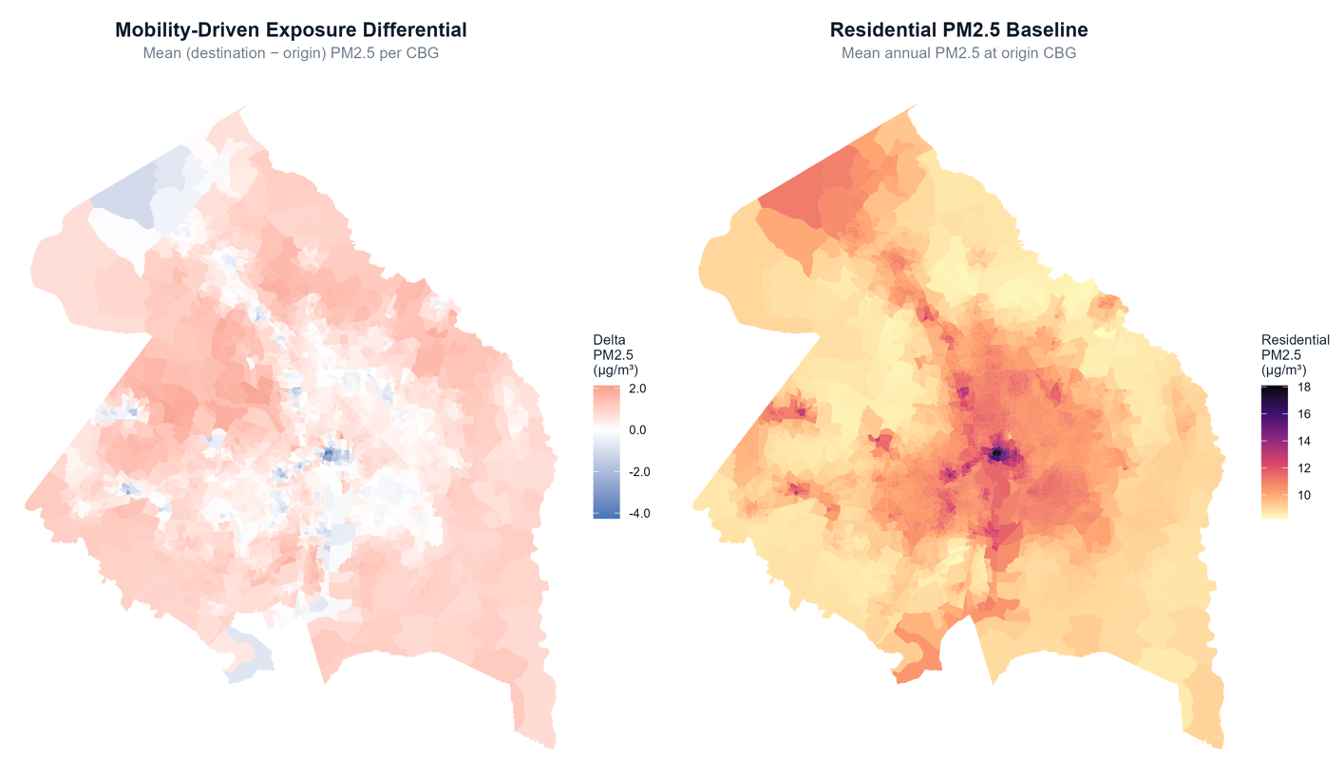
Figure 1. Mobility-driven PM_{2.5} differential (left) and residential PM_{2.5} baseline (right) across DMV CBGs, 2018-2021. The inverse spatial pattern reflects the structural relationship between where people live and where they can travel.

3.2 Demographic Drivers: Transit Dependence vs. Race
Quartile analysis reveals a contrast between the gradients for transit dependence and race. CBGs in the lowest no-vehicle quartile (fewest car-free households, most car-owning) show a mean mobility delta of +0.676 µg/m³; the highest no-vehicle quartile (most car-free) shows +0.050 µg/m³, a 13-to-1 gradient. The mechanism is geographic: car-owning suburban CBGs commute into DC employment corridors that are substantially more polluted than their suburban neighborhoods, while car-free CBGs are concentrated in the urban core where destinations are in the same high-pollution environment as origins.
In contrast, the raw quartile gradient for percent nonwhite is nearly flat. This absence of a simple racial gradient is counterintuitive relative to the standard EJ literature,¹⁵ but is explained by the spatial trap: the most non-white CBGs are predominantly in the urban core, where high residential PM_{2.5} limits mobility differential. The racial disparity is not in the mean but in the mechanism, as the interaction model below reveals.
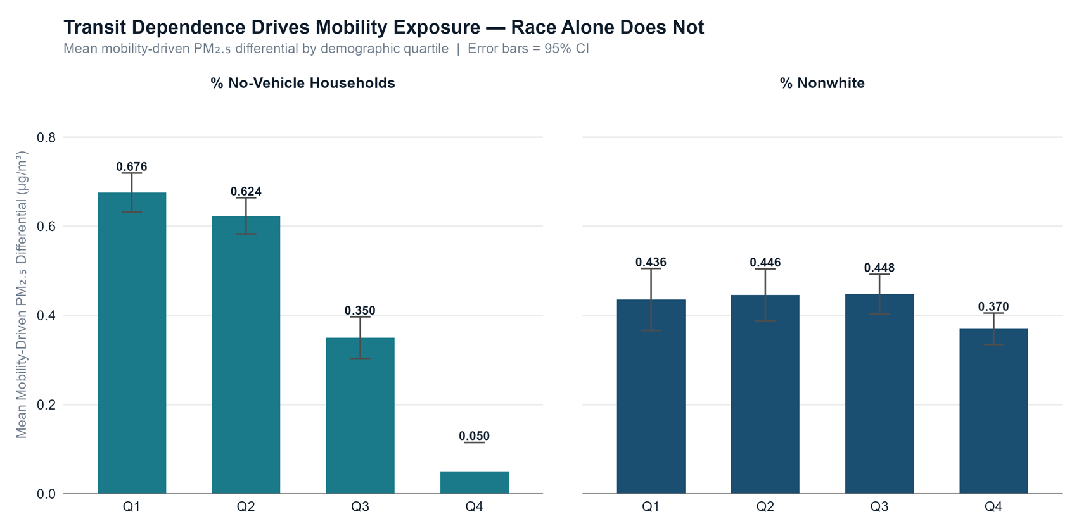

Figure 2. Mean mobility-adjusted PM_{2.5} differential by demographic quartile. Left: no-vehicle households (Q1 lowest, Q4 highest) show a strong negative gradient (0.676 to 0.050). Right: percent nonwhite shows near-flat pattern (0.437 to 0.371). Error bars = ±1 SE.
3.3 Temporal Trends and Seasonal Structure
Mobility-driven PM_{2.5} differentials exhibit strong seasonality. Mean delta PM_{2.5} peaks in December (0.738 µg/m³) and reaches its annual minimum in June (0.212 µg/m³) - a roughly 3.5-fold seasonal range. This pattern reflects how winter PM_{2.5} accumulation is driven by increased fuel burning for heat and temperature inversions that trap air pollution near the surface, preventing dispersion and amplifying urban-suburban spatial gradients. while summer months show more spatially uniform distributions as these conditions subside.¹⁶
Annual mean ΔPM_{2.5} was +0.675 µg/m³ in 2018, +0.528 in 2019, +0.266 in 2020, and +0.208 in 2021. The pre-COVID peak in 2018 was thus higher than 2019; we use the 2019 vs. 2020 comparison for the COVID analysis to avoid confounding 2018's unusually high values. The overall trajectory shows a substantial and sustained compression of mobility-driven exposure during the pandemic period.
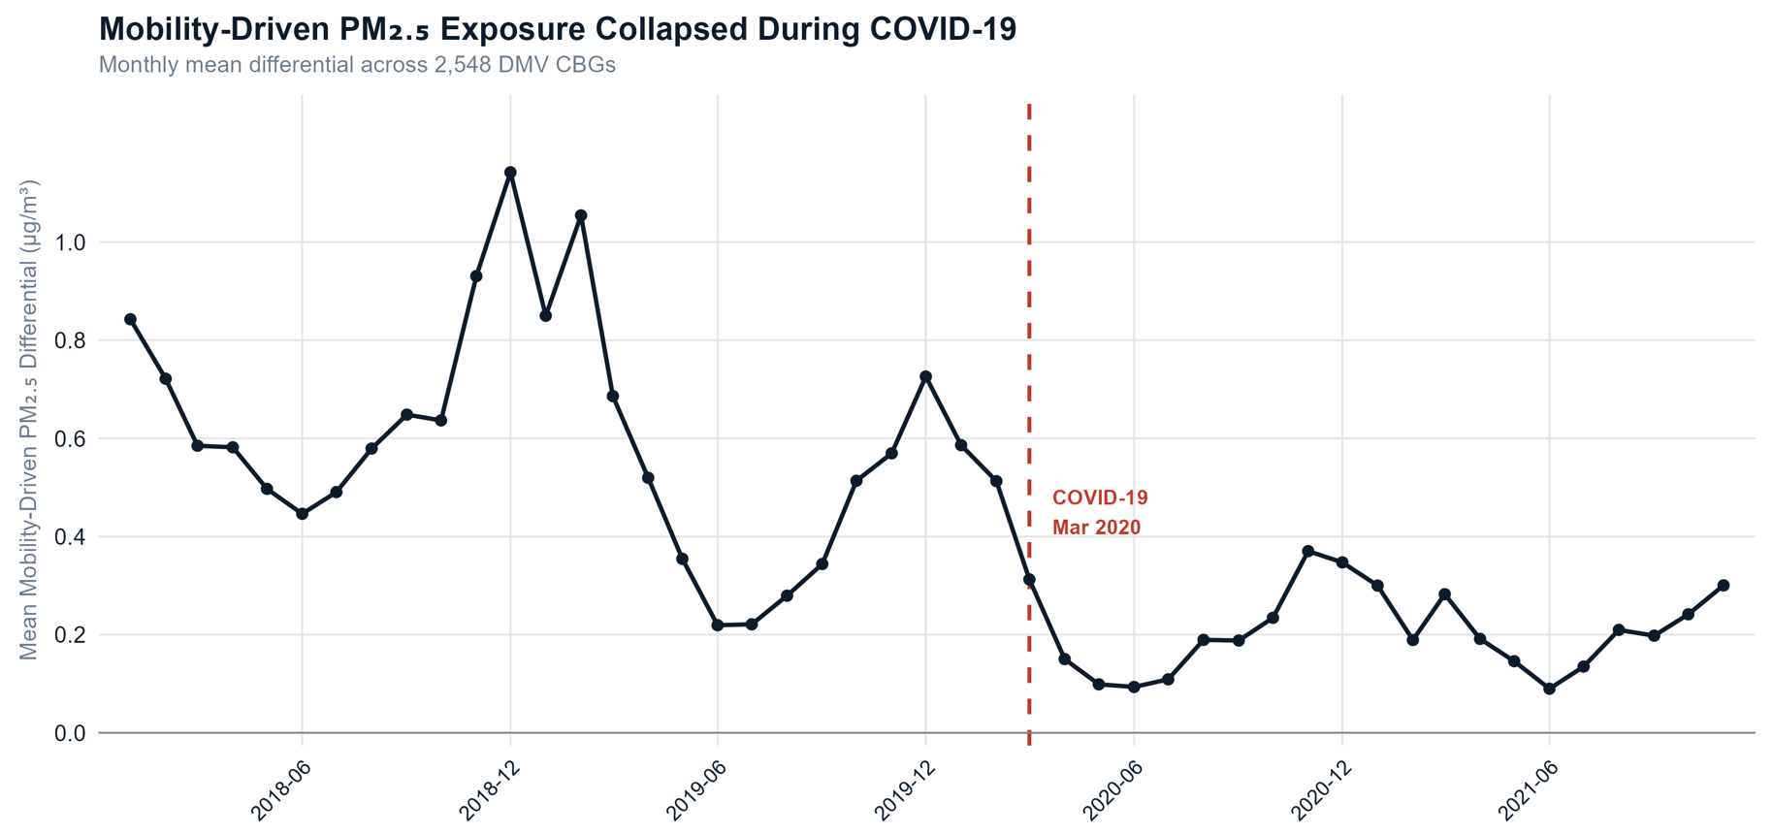
Figure 3. Monthly mean ΔPM_{2.5} across DMV CBGs, January 2018-November 2021. Red dashed line marks COVID-19 onset (March 2020). Strong seasonality and pandemic-period suppression are both visible.
3.4 Spatial Regression Results
Table 1 presents key coefficients across all four model specifications. The OLS baseline (M1) achieves R² = 0.844 but has Moran's I = 0.612 on residuals, confirming severe spatial autocorrelation that invalidates standard errors and produces biased estimates. The spatial error model (M2) reduces residual Moran's I to -0.157 (p = 1.0, confirming complete elimination of spatial clustering in residuals), improves AIC by over 4,500 points (539.6 to -3,979.3), and yields λ = 0.984, indicating that nearly all geographic clustering is absorbed by the spatial error.
Table 1. Spatial Regression Model Comparison - Key Coefficients
Variable | M1 OLS | M2 SEM | M3 SLM | M4 SEM+Int.
pct_nonwhite | 0.00163*** | 0.00072*** | 0.00091** | 0.00587***
log_median_income | 0.1068*** | -0.0131 | 0.0883*** | -0.0141
pct_no_vehicle | 0.01317*** | 0.00088*** | 0.01008*** | 0.00098***
pct_college | 0.00614*** | 0.00180*** | 0.00380*** | 0.00175***
residential_pm25 | -0.5837*** | -0.8887*** | -0.3660*** | -0.8639***
pct_nonwhite residential_pm25 | — | — | — | -0.00051***
Spatial parameter | — | λ = 0.984 | ρ = 0.471 | λ = 0.984
AIC | 539.6 | -3,979.3 | -64.1 | -4,001.6
Note: ***p < 0.001, **p < 0.01, *p < 0.05. Dependent variable is mean delta PM_{2.5}₅ (µg/m³). M2 is the base spatial error model; M4 (SEM with interaction) is the primary model. N = 2,419 CBGs.
The base SEM (M2) confirms a small but statistically significant racial disparity: a one percentage point increase in nonwhite share predicts a +0.00072 µg/m³ increase in mobility differential after controlling for all other variables and spatial structure (p < 0.001). Income, by contrast, loses significance entirely once spatial autocorrelation is controlled (p = 0.081), a reversal from its strong OLS coefficient (+0.107, p < 0.001). This sign flip reveals that the OLS income result was geographic confounding: high income and high mobility delta both cluster in the suburban ring, so OLS attributed a causal effect to income that was capturing spatial sorting. Transit dependence and college education remain significant, with college education showing the largest IQR effect (+0.073 µg/m³), consistent with the pattern of college-educated suburban professionals commuting into DC employment centers.
3.5 The Spatial Trap: Interaction of Race and Residential PM_{2.5}
The primary model (M4) tests whether the effect of racial composition on mobility-driven exposure varies by residential PM_{2.5} level. The interaction term (percent nonwhite and residential exposure) is -0.00051 (p < 0.001), and M4 significantly improves on M2 (LR test: χ² = 24.252, p < 0.001; AIC: -4,001.6 vs. -3,979.3), confirming explanatory power. The spatial error parameter remains stable at λ = 0.984 in both models.
Marginal effect analysis illustrates how this plays out spatially. At the 25th percentile of residential PM_{2.5}, typical of clean-air suburbs, a one percentage point increase in nonwhite share predicts a +0.00117 µg/m³ higher mobility delta. By the 75th percentile, typical of the DC urban core, this effect shrinks to +0.00039, a 66.8% reduction. Nonwhite residents in suburban areas commute into worse air, generating a positive race-mobility relationship. But nonwhite residents in already-polluted urban environments have no mobility pathway to cleaner air; they face high PM_{2.5} at home and high PM_{2.5} wherever they travel, a double disadvantage difficult to find through residential research.
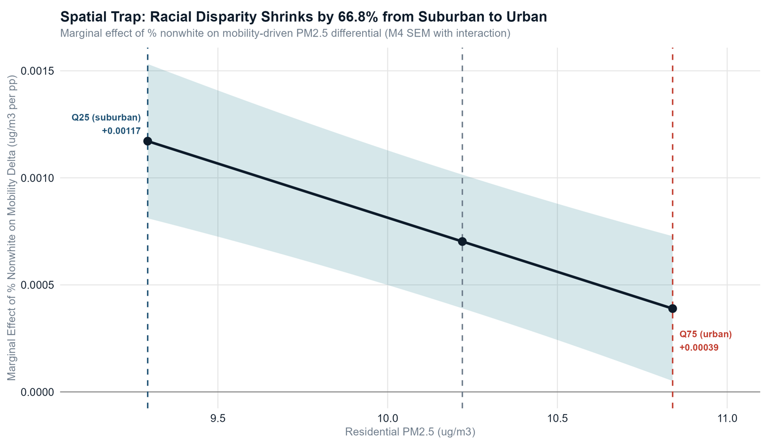
Figure 4. Marginal effect of percent nonwhite on mean delta PM_{2.5} as a function of residential PM_{2.5} (M4 SEM with interaction).
3.6 COVID-19 Natural Experiment
The COVID-19 pandemic caused a 50% collapse in the mobility-driven PM_{2.5} differential: from +0.528 µg/m³ in 2019 to +0.266 in 2020 (paired t-test: mean difference = -0.262 µg/m³, p < 0.001). The differential remained suppressed at +0.208 in 2021. This collapse is visible in flow map comparisons: pre-COVID SafeGraph patterns show dense, long-range commuting flows from Germantown, MD, Fairfax, VA, and other suburbs into DC; COVID-era flows are sparse and short-range, with long-distance suburban commuting largely absent.
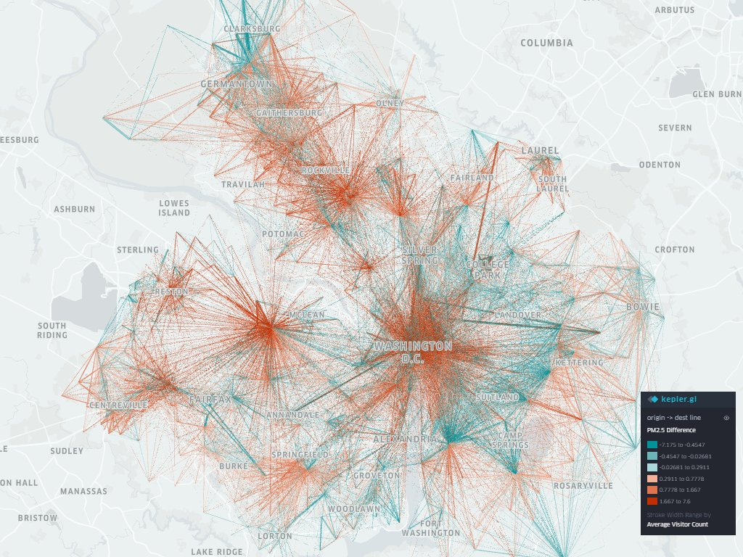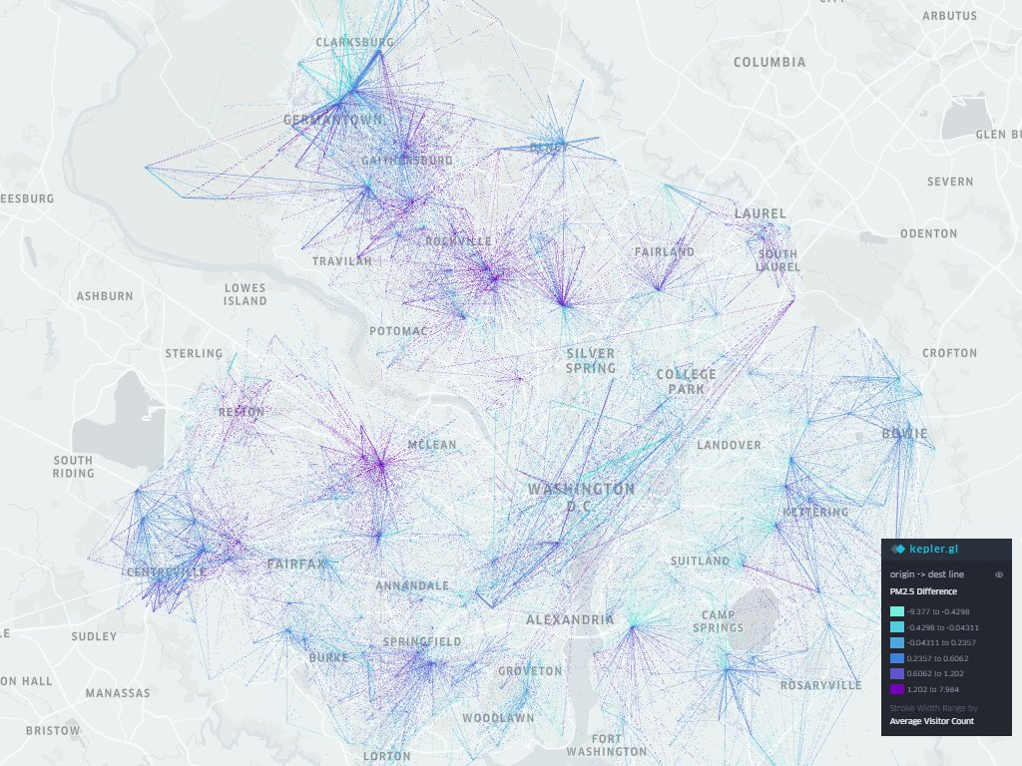
Figure 5. Origin-destination mobility flows across the Washington, D.C. metropolitan area, 2019 (pre-COVID, left) and 2020 (COVID era, right). Lines connect origin and destination census block groups, colored by PM_{2.5} difference between destination and origin (red/purple = traveling into worse air; teal/blue = traveling into cleaner air), with line thickness scaled to visitor volume.
Table 2 presents the standardized SEM coefficients by period. The percent nonwhite coefficient is 0.02039 in the pre-COVID period and 0.01879 in the COVID era - a modest reduction that is not statistically significant, indicating the racial structure of exposure disparity persisted even with suppressed mobility. In contrast, percent no-vehicles drops by 56 precent and percent college drops 60 percent, consistent with the interpretation that transit-dependent and suburban-professional commuting patterns are more sensitive to mobility volume than race-based patterns. The residential exposure coefficient also attenuates substantially across periods (from -1.335 to -0.891), reflecting the compression of spatial PM_{2.5} gradients during the pandemic.
Table 2. Standardized SEM Coefficients: Pre-COVID (2018-2019) vs. COVID Era (2020-2021)
Variable | Pre-COVID β (SE) | COVID Era β (SE) | Change
pct_nonwhite | 0.02039*** (0.00600) | 0.01879*** (0.00403) | -0.00160 (stable)
log_income | -0.01149* (0.00504) | -0.00114 (0.00339) | +0.01035 (attenuated)
pct_no_vehicle | 0.01857*** (0.00489) | 0.00825* (0.00328) | -0.01032 (compressed)
pct_college | 0.06201*** (0.00633) | 0.02508*** (0.00425) | -0.03693 (compressed)
residential_pm25 | -1.33505*** (0.01151) | -0.89147*** (0.00593) | -44.358 (attenuated)
Note: All predictors are standardized (z-scored). ***p < 0.001, *p < 0.05. Spatial error models with queen contiguity weights estimated separately for each period.
4. Discussion
This study demonstrates that human mobility is a structurally important but overlooked part of environmental injustice in the DMV. The finding that 80.7% of the region's population lives in CBGs where daily travel increases PM_{2.5} exposure by a mean of +0.451 µg/m³ establishes the scale of what residential methods miss. But the more substantive contribution is the identification of the spatial trap: nonwhite communities in already-polluted urban areas face a compound disadvantage that is invisible to residential exposure analysis because it operates at the intersection of where people live and where the pollution ceiling prevents escape through travel.
The transit dependence deserves particular emphasis. The 13-to-1 gradient in mobility delta between the lowest and highest no-vehicle quartiles represents a substantial descriptive disparity. Importantly, this pattern does not indicate that car-free populations experience lower pollution burdens overall. Rather, it reflects differences in how mobility alters exposure across urban and suburban contexts. Car-owning suburban CBGs account for most of the mobility-driven exposure because residents typically commute from comparatively cleaner residential environments into the higher PM_{2.5} employment corridor concentrated in Washington, DC. In contrast, car-free CBGs, which are concentrated in the urban core, exhibit lower mobility differential because daily travel occurs within the same already-polluted environment in which residents live. Their mobility therefore produces relatively little additional exposure beyond an already elevated residential baseline. This distinction has important policy implications. Efforts to reduce mobility-driven exposure disparities should primarily target the suburban-to-urban commuting corridor, where transportation-related movement substantially increases exposure. Meanwhile, car-free urban populations may require a different policy approach focused less on commuting patterns and more on reducing chronic residential exposure in high-pollution neighborhoods.
The reversal of the income coefficient between the OLS model (+0.107, p < 0.001) and the SEM model (-0.013, p = 0.081) highlights the methodological risks of ignoring spatial autocorrelation in environmental justice research.¹² In the OLS specification, the positive association between income and mobility differential largely reflected geographic sorting rather than an independent socioeconomic effect. Once the SEM accounts for spatially correlated error, the income effect becomes statistically insignificant, suggesting that income itself does not independently drive mobility-related exposure disparities. This result aligns with the distinctive economic geography of the DMV region, where high-income professional employment is concentrated within the higher PM_{2.5} downtown DC area. As a result, affluent suburban residents often commute into more polluted employment centers, generating a positive correlation between income and destination pollution that may not appear in more spatially dispersed metropolitan labor markets.
The COVID-19 period further strengthens the causal interpretation of these findings. Venter et al. documented substantial global air quality improvements following pandemic-related mobility restrictions, demonstrating that travel behavior, not only stationary emissions sources, plays a significant role in shaping ambient pollution exposure.¹⁸ In the DMV region, the pandemic reduction in mobility was largely exogenous to both local pollution patterns and neighborhood demographic composition. Consequently, the observed 50% compression in mobility-driven exposure differentials can be more attributed to reduced travel intensity rather than to any fundamental change in the spatial distribution of PM_{2.5} concentrations. At the same time, the relative persistence of the racial disparity across periods is notable. The percent nonwhite coefficient changed by only 7.8%, whereas transit-dependence and educational attainment effects reduced substantially during the COVID period. This difference suggests that the racial disparity is driven by long-standing spatial inequalities rather than by temporary differences in travel volume. Even during the COVID-19 mobility collapse, predominantly nonwhite communities remained more likely to live in and travel within higher PM_{2.5} environments, indicating that short-term reductions in movement did not alter the underlying geography of exposure.
4.1 Limitations
Several limitations should be acknowledged. First, the SafeGraph panel represents smartphone users who opted into location tracking and likely underrepresents Hispanic, low-income, and older populations.¹⁹ Because these populations are disproportionately represented among environmentally burdened communities, the observed demographic gradients in mobility-driven exposure are likely conservative. The true magnitude of disparity may therefore be larger than estimated here. Second, SafeGraph’s POI-based framework captures visits to registered commercial and institutional destinations but excludes many informal or in-transit environments, including parks, sidewalks, residential visits, and transit vehicle interiors. Prior research demonstrates that PM_{2.5} concentrations inside buses and subway cars can substantially exceed ambient outdoor levels,²⁰ suggesting that the exposure differentials estimated in this study likely represent a lower bound of actual mobility-related burden.
Third, demographic variables from the 2019 American Community Survey are treated as temporally static across the full 47-month study period. This assumption may introduce measurement error during the COVID-19 period, when residential mobility and neighborhood demographic change accelerated in many metropolitan areas.²¹ Fourth, the analysis is conducted at the census block group level and therefore cannot identify individual-level exposure trajectories or account for person-specific confounders such as occupation, commuting mode, residential tenure, or household vehicle ownership. The observed relationships should therefore be interpreted as area-level associations rather than individual causal effects.
Finally, the identified “spatial trap” concept may be specific to the geographic structure of the DMV region. The DMV combines strong racial residential segregation with a pollution-intensive employment core concentrated in central Washington, DC. Metropolitan regions with different urban forms, commuting structures, or pollution source distributions may exhibit different mobility–exposure relationships.
5. Conclusions
This study establishes that human mobility is a structurally important but underrecognized pathway through which environmental inequities are realized in the Washington, D.C. metropolitan area. Five findings stand out. First, residential PM_{2.5} methods understate true exposure burden, with 80.7% of the DMV population regularly traveling into more polluted air than they live in. Second, transit dependence, not racial composition in isolation, is the primary demographic driver of mobility-driven exposure. Third, income shows no independent effect on mobility exposure in spatial models, with its apparent OLS effect entirely explained by geographic confounding. Fourth, the spatial trap concept, in which the marginal effect of nonwhite share on mobility exposure shrinks by 67.8% from suburban to urban residential PM_{2.5} levels, reveals a disadvantage that residential EJ research cannot detect. Fifth, the COVID-19 mobility collapse, which halved the exposure differential in 2020–2021, provides experimental evidence that daily travel is causally responsible for generating this excess burden.
These findings have direct implications for EJ policy and research methodology. Residential exposure metrics cannot capture the mobility-driven component of environmental burden. Destination-based or mobility-weighted exposure frameworks should be incorporated into health impact assessments, transportation planning, and regulatory EJ screening processes. Policy interventions should primarily target the suburban-to-urban commute corridor, where mobility produces the largest increases in PM_{2.5} exposure. Potential strategies include transit electrification, emissions controls or clean-air corridors along major commuter arterials, and urban greening investments at high-traffic destination areas disproportionately visited by nonwhite suburban commuters.
The analytical framework developed in this study, combining Global Hybrid PM2.5 Dataset satellite-derived PM_{2.5} estimates, SafeGraph mobility flows, and American Community Survey demographic data within a reproducible spatial regression pipeline, is also transferable to other metropolitan regions where comparable datasets are available. This approach provides a scalable framework for evaluating mobility-driven environmental inequality in metropolitan areas such as Houston, Chicago, and Los Angeles, where different urban forms and commuting structures may produce distinct exposure dynamics.
Acknowledgments
The author thanks Professor Junjun Yin for guidance and mentorship throughout this project and for providing the access to SafeGraph mobility data. GHAP PM_{2.5} data were obtained from the publicly available Zenodo repository. ACS data were accessed via the U.S. Census Bureau API. All spatial regression analyses were conducted in R²² using the spdep and spatialreg packages. Data processing and mobility flow aggregation were performed in Python using GeoPandas²³ and Rasterio.²⁴ Flow map visualizations were produced with kepler.gl.²⁵ This project was conducted with the assistance of Claude, an AI language model.
Data Availability
All analysis code and processed datasets (excluding proprietary SafeGraph data, which must be requested independently) are available at https://github.com/jhson17/dmv-mobility-pm25. GHAP PM_{2.5} data are freely available via Zenodo. ACS data are available from the U.S. Census Bureau. Access to SafeGraph data for academic research may be requested through the SafeGraph Research Partners program.

References
(1) Cohen, A. J.; Brauer, M.; Burnett, R.; Anderson, H. R.; et al. Estimates and 25-year trends of the global burden of disease attributable to ambient air pollution: an analysis of data from the Global Burden of Diseases Study 2015. Lancet 2017, 389 (10082), 1907-1918.
(2) Mikati, I.; Benson, A. F.; Luben, T. J.; Sacks, J. D.; Richmond-Bryant, J. Disparities in distribution of particulate matter emission sources by race and poverty status. Am. J. Public Health 2018, 108 (4), 480-485.
(3) Executive Office of the President. Tackling the Climate Crisis at Home and Abroad, Exec. Order No. 14,008, 86 Fed. Reg. 7619 (Jan. 27, 2021).
(4) Dons, E.; Int Panis, L.; Van Poppel, M.; Theunis, J.; Wets, G. Personal exposure to black carbon in transport microenvironments. Atmos. Environ. 2012, 55, 392-398.
(5) Dias, D.; Tchepel, O. Spatial and temporal dynamics in air pollution exposure assessment. Int. J. Environ. Res. Public Health 2018, 15 (3), 558.
(6) Su, J. G.; Jerrett, M.; Meng, Y. Y.; Pickett, M.; Rich, P. M. Integrating smart-phone based momentary location tracking with fixed site air quality monitoring for personal exposure assessment. Sci. Total Environ. 2015, 506-507, 518-526.
(7) Jbaily, A.; Zhou, X.; Liu, J.; Lee, T. H.; Kamareddine, L.; Verguet, S.; Dominici, F. Air pollution exposure disparities across US population and income groups. Nature 2022, 601 (7892), 228-233.
(8) United States Census Bureau. American Community Survey 5-Year Estimates, 2019; U.S. Census Bureau: Washington, D.C., 2020.
(9) Wei, J.; Li, Z.; Lyapustin, A.; Sun, L.; Peng, Y.; Xue, W.; Su, T.; Cribb, M. Reconstructing 1-km-resolution high-quality PM2.5 data records from 2000 to 2018 in China: spatiotemporal variations and policy implications. Remote Sens. Environ. 2021, 252, 112136.
(10) SafeGraph Inc. SafeGraph Monthly Patterns: Technical Documentation, v2.1; SafeGraph: San Francisco, CA, 2021.
(11) United States Census Bureau. American Community Survey: Understanding ACS, 5-Year Estimates; U.S. Census Bureau: Washington, D.C., 2020.
(12) Anselin, L. Spatial Econometrics: Methods and Models; Kluwer Academic Publishers: Dordrecht, 1988.
(13) Anselin, L.; Bera, A. K.; Florax, R.; Yoon, M. J. Simple diagnostic tests for spatial dependence. Reg. Sci. Urban Econ. 1996, 26 (1), 77-104.
(14) U.S. Environmental Protection Agency. National Ambient Air Quality Standards for Particulate Matter. Fed. Reg. 2024, 89 (41), 16202-16240.
(15) Hajat, A.; Hsia, C.; O’Neill, M. S. Socioeconomic disparities and air pollution exposure: a global review. Curr. Environ. Health Rep. 2015, 2 (4), 440-450.
(16) Di, Q.; Kloog, I.; Koutrakis, P.; Lyapustin, A.; Wang, Y.; Schwartz, J. Assessing PM2.5 exposures with high spatiotemporal resolution across the continental United States. Environ. Sci. Technol. 2016, 50 (9), 4712-4721.
(17) Chakraborty, J.; Maantay, J. A.; Brender, J. D. Disproportionate proximity to environmental health hazards: methods, models, and measurement. Am. J. Public Health 2011, 101 (Suppl 1), S27-S36.
(18) Venter, Z. S.; Aunan, K.; Chowdhury, S.; Lelieveld, J. COVID-19 lockdowns cause global air pollution declines. Proc. Natl. Acad. Sci. U.S.A. 2020, 117 (32), 18984-18990.
(19) Kang, Y.; Gao, S.; Liang, Y.; Li, M.; Rao, J.; Kruse, J. Multiscale dynamic human mobility flow dataset in the U.S. during the COVID-19 epidemic. Sci. Data 2020, 7 (1), 390.
(20) Moreno, T.; Reche, C.; Rivas, I.; Cruz Minguillón, M.; et al. Urban air quality comparison for bus, tram, subway and pedestrian commutes in Barcelona. Environ. Int. 2015, 84, 100-110.
(21) Haslag, P.; Weagley, D. From L.A. to Boise: How Migration Has Changed During the COVID-19 Pandemic. SSRN Working Paper 2021.
(22) R Core Team. R: A Language and Environment for Statistical Computing; R Foundation for Statistical Computing: Vienna, Austria, 2025.
(23) Jordahl, K.; Van den Bossche, J.; Fleischmann, M.; Wasserman, J.; McBride, J.; Gerard, J.; et al. geopandas/geopandas v0.14.0; Zenodo, 2023.
(24) Gillies, S.; et al. Rasterio: Geospatial Raster I/O for Python Programmers; Mapbox, 2013-2024.
(25) Uber Technologies. kepler.gl: Geospatial Analysis Tool for Large-scale Data Sets; 2024.
(26) Anthropic. Claude (claude-sonnet-4-6); Anthropic: San Francisco, CA, 2025.

